Midterm Exam: Java GUI Debugging & UI Modification Activity
Project: Elegant Java Swing Login System
Language: Java
GUI: Java Swing
Difficulty: Beginner → Intermediate
Number of Questions: 25
Score: 100 points

Student Instructions
For each problem:
- Open the existing LoginApp.java.
- Identify the section of code responsible for the behavior or UI.
- Modify the code.
- Compile and run the application.
- Verify that the requested change works.
- Take a screenshot of the result when required.

Part I — Basic UI Modification

Question 1 — Change the Window Title
The current application title is:
Secure Login
Task: Modify the Java code so that the window title becomes:
Student Login System
Requirement: The title must appear in the application's title bar.

Question 2 — Resize the Login Window
The current window size is:
setSize(850, 520);
Task: Change the window size to:
1000 × 600 pixels
The application must remain properly centered on the screen.
Debugging objective: Identify the method controlling the JFrame dimensions.

Question 3 — Change the Primary Color
The current primary color is:
new Color(37, 99, 235)
Task: Change the application's primary color to a dark green.
For example:
new Color(22, 101, 52)
Apply the new color to the major buttons and left-side panel.

Question 4 — Change the Application Background
The current background is:
private final Color BACKGROUND = new Color(245, 247, 251);
Task: Change the background to a light gray:
RGB: 235, 238, 242
Run the program and verify that the Dashboard also uses the new background.

Question 5 — Change the Login Heading
The current heading is:
Sign In
Task: Change it to:
Student Portal Login
The heading must remain bold and clearly visible.

Part II — Debugging Components

Question 6 — Username Field Does Not Appear
Suppose the following line is accidentally removed:
rightPanel.add(usernameField);
Task:
- Identify why the username field is no longer visible.
- Restore the necessary code.
- Run the program and verify that the field appears.
Question: What is the purpose of:
rightPanel.add(usernameField);

Question 7 — Password Field Is Not Masked
Suppose the password appears as normal text:
Password: 12345
instead of:
Password: •••••
Task: Modify the program so that the password is masked when the application starts.

Question 8 — Show Password Is Not Working
The Show Password checkbox is visible, but clicking it does nothing.
Task: Debug the event listener and make the checkbox perform these actions:
Unchecked → •••••••
Checked → 12345
Requirement: Clicking the checkbox again must hide the password.

Question 9 — Clear Button Does Not Clear the Password
The CLEAR button currently clears the username but leaves the password.
Task: Modify the clearFields() method so that both fields are cleared.
Expected result:
Before:

Username: student
Password: 12345

↓ CLEAR

Username:
Password:

Question 10 — Cursor Should Return to Username
After clicking CLEAR, the cursor should automatically return to the username field.
Task: Modify the program so that:
usernameField.requestFocus();
is executed after clearing the fields.
Question: Why is requestFocus() useful in a login interface?

Part III — Login Functionality Debugging

Question 11 — Empty Fields
Currently, a user should not be allowed to log in if the username or password is empty.
Task: Modify/debug the login validation so that these cases display an error:
Username: [blank]
Password: 12345
and:
Username: student
Password: [blank]

Question 12 — Incorrect Login Message
Change the error message from:
Invalid username or password.
to:
Login failed. Please check your username and password.
The message should appear using JOptionPane.

Question 13 — Successful Login
When valid credentials are entered, the program currently displays:
Login successful!
Task: Change the message to:
Welcome! You have successfully logged in.
After clicking OK, the Dashboard must open.

Question 14 — Debug the Username Comparison
Suppose the following code is used:
if (storedUsername == username) {
return true;
}
Task:
- Explain why this comparison can cause a problem in Java.
- Replace it with the correct comparison.
- Test the login.
Expected concept: Students should recognize the difference between == and .equals() when comparing String values.

Question 15 — Case-Insensitive Username
Currently:
student
and:
Student
are considered different usernames.
Task: Modify the login system so that the username is case-insensitive, while the password remains case-sensitive.
Example:
student / 12345
Student / 12345
STUDENT / 12345
All should authenticate the same account.

Part IV — UI Enhancement

Question 16 — Add an Eye Icon/Button
The current password field only has a Show Password checkbox.
Task: Modify the UI to add an eye button/icon beside the password field.
Expected behavior:
Password: [••••••••••] 👁
Clicking the eye:
Password: [123456789] 👁
Clicking it again hides the password.

Question 17 — Add a Login Icon
Modify the SIGN IN button so that it includes an appropriate login/arrow icon.
Expected appearance:
→ SIGN IN
The button should remain aligned and professional.

Question 18 — Change Button Hover Effect
The current button changes color when the mouse enters it.
Task: Modify the hover effect so that the button becomes noticeably darker when the mouse enters and returns to its original color when the mouse leaves.
Additional requirement: The mouse cursor should change to a hand cursor.

Question 19 — Change Font
The current application uses:
new Font("Arial", ...)
Task: Change the application's main font to another installed font, such as:
Segoe UI
Apply it consistently to:
- Login heading
- Labels
- Text fields
- Buttons
- Registration screen

Question 20 — Improve Text Field Appearance
The username and password fields currently have a simple rectangular border.
Task: Modify the UI so that the fields have:
- Increased internal padding
- A more visible border
- Rounded appearance if possible
- Consistent height
- Consistent width
The final interface should look more modern.

Part V — Intermediate Debugging Challenges

Question 21 — Registration Window Does Not Open
Suppose clicking:
Create Account
does nothing.
Task: Debug the event listener and make the Registration dialog appear.

Expected Out:
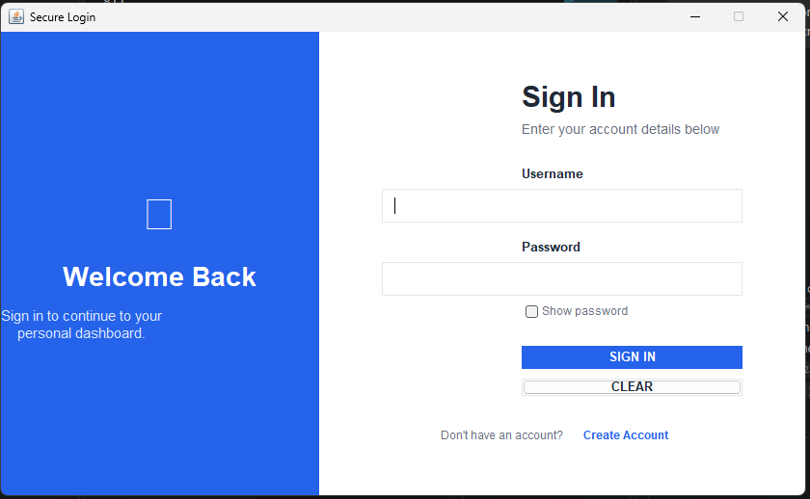

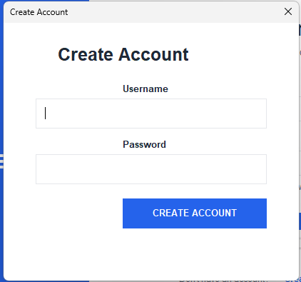

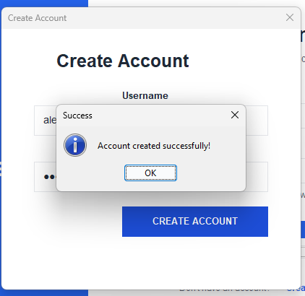

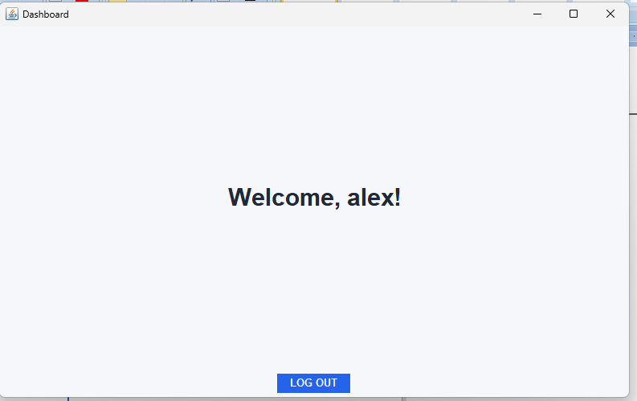

Question 22 — Duplicate Username Bug
Suppose the following users already exist:
student
admin
teacher
A user attempts to register:
student
The system currently allows the registration.
Task: Debug the userExists() method so that duplicate usernames cannot be registered.
Expected result:
Username already exists.

Question 23 — Fix the Text File Format
The program stores users in this format:
username|passwordHash
Suppose a student changes the code and accidentally writes:
username,passwordHash
Task:
- Identify why login stops working.
- Correct the delimiter.
- Ensure the login system correctly reads the data.
Question: Why does the program use:
split("\\|")
?

Question 24 — File Does Not Exist
When the program starts for the first time, users.txt does not exist.
Task: Modify the program so that it can still run without crashing.
When the first user registers, the program should automatically create:
users.txt

Question 25 — Final UI Challenge
Modify the existing application to produce your own professional Student Login System.
The interface must contain:

Login Screen
┌─────────────────────────────────────────────────────────┐
│ │
│ Welcome Back Student Portal │
│ Login │
│ │
│ [ Logo ] Username │
│ Welcome Back [________________] │
│ │
│ Sign in to continue Password │
│ to your dashboard [••••••••••••] 👁 │
│ │
│ ☑ Show password │
│ │
│ [ SIGN IN ] │
│ │
│ [ CLEAR ] │
│ │
│ Create Account │
│ │
└─────────────────────────────────────────────────────────┘

